SD image:
https://sourceforge.net/projects/udooboard/files/UDOO_Quad/UDOObuntu/UDOObuntu_quad_v1.1.zip/download

(08:29 ubuntu@udoobuntu libraries) > sudo passwd root
Enter new UNIX password: rootatusspsp
Retype new UNIX password:
passwd: password updated successfully
(08:29 ubuntu@udoobuntu libraries) >
(08:29 ubuntu@udoobuntu libraries) > su - root
Password:
(08:30 root@udoobuntu ~) > dpkg-reconfigure tzdata

Current default time zone: 'Asia/Shanghai'
Local time is now: Thu Apr 2 16:31:44 CST 2015.
Universal Time is now: Thu Apr 2 08:31:44 UTC 2015.

(16:31 root@udoobuntu ~) >

(16:31 root@udoobuntu ~) > apt-get update
(16:32 root@udoobuntu ~) > apt-get upgrade
Reading package lists... Done
Building dependency tree
Reading state information... Done
The following packages have been kept back:
lubuntu-software-center totem
0 upgraded, 0 newly installed, 0 to remove and 2 not upgraded.
(16:36 root@udoobuntu ~) > sed -i 's/udoobuntu/ihost/g' /etc/hostname
(16:36 root@udoobuntu ~) > cat /etc/hostname
ihost
(16:36 root@udoobuntu ~) >

(16:38 root@udoobuntu ~) > sed -i 's/udoobuntu/ihost/g' /etc/hosts
(16:38 root@udoobuntu ~) > cat /etc/hosts
127.0.0.1 localhost
127.0.0.1 ihost
::1 localhost ip6-localhost ip6-loopback
fe00::0 ip6-localnet
ff00::0 ip6-mcastprefix
ff02::1 ip6-allnodes
ff02::2 ip6-allrouters

(16:38 root@udoobuntu ~) >

(16:38 root@udoobuntu ~) > uname -a
Linux udoobuntu 3.0.35 #7 SMP PREEMPT Thu Jul 3 15:12:59 CEST 2014 armv7l armv7l armv7l GNU/Linux
(16:39 root@udoobuntu ~) > ls -la /etc/udev/rules.d/
total 20K
drwxr-xr-x 2 root root 4.0K Apr 17 2014 .
drwxr-xr-x 3 root root 4.0K Dec 13 2013 ..
-rw-r--r-- 1 root root 1.7K Apr 17 2014 10-imx.rules
-rw-r--r-- 1 root root 306 Dec 13 2013 70-persistent-cd.rules
-rw-r--r-- 1 root root 0 Apr 17 2014 75-persistent-net-generator.rules
-rw-r--r-- 1 root root 1.2K Apr 6 2012 README
(16:40 root@udoobuntu ~) > cat /etc/udev/rules.d/70-persistent-cd.rules
# This file maintains persistent names for CD/DVD reader and writer devices.
# See udev(7) for syntax.
#
# Entries are automatically added by the 75-cd-aliases-generator.rules
# file; however you are also free to add your own entries provided you
# add the ENV{GENERATED}=1 flag to your own rules as well.
(16:40 root@udoobuntu ~) >

(16:41 root@udoobuntu ~) > cat /etc/network/interfaces
# interfaces(5) file used by ifup(8) and ifdown(8)
auto lo
iface lo inet loopback

(16:41 root@udoobuntu ~)
(16:41 root@udoobuntu ~) > cat /etc/resolv.conf
nameserver 8.8.8.8
(16:42 root@udoobuntu ~)

(16:57 root@udoobuntu ~) > mount -l
rootfs on / type ext3 (rw,noatime)
none on /proc type proc (rw,noexec,nosuid,nodev)
none on /sys type sysfs (rw,noexec,nosuid,nodev)
devtmpfs on /dev type devtmpfs (rw,mode=0755)
none on /dev/pts type devpts (rw,noexec,nosuid,gid=5,mode=0620)
none on /sys/fs/fuse/connections type fusectl (rw)
none on /sys/kernel/debug type debugfs (rw)
none on /run type tmpfs (rw,noexec,nosuid,size=10%,mode=0755)
none on /run/lock type tmpfs (rw,noexec,nosuid,nodev,size=5242880)
none on /run/shm type tmpfs (rw,nosuid,nodev)
gvfs-fuse-daemon on /home/ubuntu/.gvfs type fuse.gvfs-fuse-daemon (rw,nosuid,nodev,user=ubuntu)
gvfs-fuse-daemon on /home/ubuntu/.gvfs type fuse.gvfs-fuse-daemon (rw,nosuid,nodev,user=ubuntu)
(16:58 root@udoobuntu ~) > df -Th
Filesystem Type Size Used Avail Use% Mounted on
rootfs ext3 6.4G 2.9G 3.2G 48% /
devtmpfs devtmpfs 438M 4.0K 438M 1% /dev
none tmpfs 88M 2.6M 85M 3% /run
none tmpfs 5.0M 0 5.0M 0% /run/lock
none tmpfs 438M 100K 438M 1% /run/shm
(16:58 root@udoobuntu ~) >

(16:58 root@udoobuntu 2015-04-02) > fdisk -l

Disk /dev/mmcblk0: 63.9 GB, 63864569856 bytes
255 heads, 63 sectors/track, 7764 cylinders, total 124735488 sectors
Units = sectors of 1 * 512 = 512 bytes
Sector size (logical/physical): 512 bytes / 512 bytes
I/O size (minimum/optimal): 512 bytes / 512 bytes
Disk identifier: 0x000c356e

Device Boot Start End Blocks Id System
/dev/mmcblk0p1 16065 13623119 6803527+ 83 Linux
(16:58 root@udoobuntu 2015-04-02) > fdisk /dev/mmcblk0

Command (m for help): p

Disk /dev/mmcblk0: 63.9 GB, 63864569856 bytes
255 heads, 63 sectors/track, 7764 cylinders, total 124735488 sectors
Units = sectors of 1 * 512 = 512 bytes
Sector size (logical/physical): 512 bytes / 512 bytes
I/O size (minimum/optimal): 512 bytes / 512 bytes
Disk identifier: 0x000c356e

Device Boot Start End Blocks Id System
/dev/mmcblk0p1 16065 13623119 6803527+ 83 Linux

Command (m for help): n
Partition type:
p primary (1 primary, 0 extended, 3 free)
e extended
Select (default p):
Using default response p
Partition number (1-4, default 2):
Using default value 2
First sector (2048-124735487, default 2048): 13623120
Last sector, +sectors or +size{K,M,G} (13623120-124735487, default 124735487):
Using default value 124735487

Command (m for help): p

Disk /dev/mmcblk0: 63.9 GB, 63864569856 bytes
255 heads, 63 sectors/track, 7764 cylinders, total 124735488 sectors
Units = sectors of 1 * 512 = 512 bytes
Sector size (logical/physical): 512 bytes / 512 bytes
I/O size (minimum/optimal): 512 bytes / 512 bytes
Disk identifier: 0x000c356e

Device Boot Start End Blocks Id System
/dev/mmcblk0p1 16065 13623119 6803527+ 83 Linux
/dev/mmcblk0p2 13623120 124735487 55556184 83 Linux

Command (m for help): w
The partition table has been altered!

Calling ioctl() to re-read partition table.

WARNING: Re-reading the partition table failed with error 16: Device or resource busy.
The kernel still uses the old table. The new table will be used at
the next reboot or after you run partprobe(8) or kpartx(8)
Syncing disks.
(17:00 root@udoobuntu 2015-04-02) > partprobe
(17:00 root@udoobuntu 2015-04-02) >

(17:01 root@udoobuntu ~) > e2label /dev/mmcblk0p1 ihost
(17:01 root@udoobuntu ~) > sync

(12:45 root@ihost ~) > mke2fs -b 4096 -t ext3 /dev/mmcblk0p2
mke2fs 1.42 (29-Nov-2011)
Discarding device blocks: done
Filesystem label=
OS type: Linux
Block size=4096 (log=2)
Fragment size=4096 (log=2)
Stride=0 blocks, Stripe width=0 blocks
3473408 inodes, 13889046 blocks
694452 blocks (5.00%) reserved for the super user
First data block=0
Maximum filesystem blocks=0
424 block groups
32768 blocks per group, 32768 fragments per group
8192 inodes per group
Superblock backups stored on blocks:
32768, 98304, 163840, 229376, 294912, 819200, 884736, 1605632, 2654208,
4096000, 7962624, 11239424

Allocating group tables: done
Writing inode tables: done
Creating journal (32768 blocks): done
Writing superblocks and filesystem accounting information: done

(12:52 root@ihost ~) >

(12:52 root@ihost ~) > e2label /dev/mmcblk0p2 data
(12:52 root@ihost ~) > sync

(17:04 root@udoobuntu ~) > apt-get install build-essential ncurses-dev uboot-mkimage git
Reading package lists... Done
Building dependency tree
Reading state information... Done
Note, selecting 'libncurses5-dev' instead of 'ncurses-dev'
build-essential is already the newest version.
build-essential set to manually installed.
The following extra packages will be installed:
git-man liberror-perl libtinfo-dev rsync u-boot-tools
Suggested packages:
git-daemon-run git-daemon-sysvinit git-doc git-el git-arch git-cvs git-svn git-email git-gui gitk gitweb ncurses-doc
The following NEW packages will be installed:
git git-man liberror-perl libncurses5-dev libtinfo-dev rsync u-boot-tools uboot-mkimage
0 upgraded, 8 newly installed, 0 to remove and 2 not upgraded.
Need to get 6174 kB of archives.
After this operation, 12.7 MB of additional disk space will be used.
Do you want to continue [Y/n]? y
Get:1 http://ports.ubuntu.com/ precise/main rsync armhf 3.0.9-1ubuntu1 [283 kB]
Get:2 http://ports.ubuntu.com/ precise/main liberror-perl all 0.17-1 [23.8 kB]
Get:3 http://ports.ubuntu.com/ precise/main git-man all 1:1.7.9.5-1 [630 kB]
Get:4 http://ports.ubuntu.com/ precise/main git armhf 1:1.7.9.5-1 [4898 kB]
Get:5 http://ports.ubuntu.com/ precise/main libtinfo-dev armhf 5.9-4 [84.0 kB]
Get:6 http://ports.ubuntu.com/ precise/main libncurses5-dev armhf 5.9-4 [192 kB]
Get:7 http://ports.ubuntu.com/ precise/main u-boot-tools armhf 2011.09-2 [52.5 kB]
Get:8 http://ports.ubuntu.com/ precise/main uboot-mkimage all 2011.09-2 [11.0 kB]
Fetched 6174 kB in 11s (547 kB/s)
Selecting previously unselected package rsync.
(Reading database ... 97316 files and directories currently installed.)
Unpacking rsync (from .../rsync_3.0.9-1ubuntu1_armhf.deb) ...
Selecting previously unselected package liberror-perl.
Unpacking liberror-perl (from .../liberror-perl_0.17-1_all.deb) ...
Selecting previously unselected package git-man.
Unpacking git-man (from .../git-man_1%3a1.7.9.5-1_all.deb) ...
Selecting previously unselected package git.
Unpacking git (from .../git_1%3a1.7.9.5-1_armhf.deb) ...
Selecting previously unselected package libtinfo-dev.
Unpacking libtinfo-dev (from .../libtinfo-dev_5.9-4_armhf.deb) ...
Selecting previously unselected package libncurses5-dev.
Unpacking libncurses5-dev (from .../libncurses5-dev_5.9-4_armhf.deb) ...
Selecting previously unselected package u-boot-tools.
Unpacking u-boot-tools (from .../u-boot-tools_2011.09-2_armhf.deb) ...
dpkg: error processing /var/cache/apt/archives/u-boot-tools_2011.09-2_armhf.deb (--unpack):
trying to overwrite '/usr/bin/fw_printenv', which is also in package u-boot-env 2013.11
Selecting previously unselected package uboot-mkimage.
Unpacking uboot-mkimage (from .../uboot-mkimage_2011.09-2_all.deb) ...
Processing triggers for ureadahead ...
Processing triggers for man-db ...
Errors were encountered while processing:
/var/cache/apt/archives/u-boot-tools_2011.09-2_armhf.deb
E: Sub-process /usr/bin/dpkg returned an error code (1)
(17:05 root@udoobuntu ~) > dpkg -i --force-overwrite /var/cache/apt/archives/u-boot-tools_2011.09-2_armhf.deb
(Reading database ... 98046 files and directories currently installed.)
Unpacking u-boot-tools (from .../u-boot-tools_2011.09-2_armhf.deb) ...
dpkg: warning: overriding problem because --force enabled:
trying to overwrite '/usr/bin/fw_printenv', which is also in package u-boot-env 2013.11
dpkg: warning: overriding problem because --force enabled:
trying to overwrite '/usr/bin/fw_setenv', which is also in package u-boot-env 2013.11
Setting up u-boot-tools (2011.09-2) ...
Processing triggers for man-db ...
(17:10 root@udoobuntu ~) > apt-get -f install
Reading package lists... Done
Building dependency tree
Reading state information... Done
0 upgraded, 0 newly installed, 0 to remove and 2 not upgraded.
(17:10 root@udoobuntu ~) >

(17:10 root@udoobuntu ~) > apt-get install build-essential ncurses-dev uboot-mkimage git
Reading package lists... Done
Building dependency tree
Reading state information... Done
Note, selecting 'libncurses5-dev' instead of 'ncurses-dev'
build-essential is already the newest version.
build-essential set to manually installed.
git is already the newest version.
libncurses5-dev is already the newest version.
uboot-mkimage is already the newest version.
0 upgraded, 0 newly installed, 0 to remove and 2 not upgraded.
7 not fully installed or removed.
After this operation, 0 B of additional disk space will be used.
Do you want to continue [Y/n]? y
Setting up rsync (3.0.9-1ubuntu1) ...
Removing any system startup links for /etc/init.d/rsync ...
Setting up git-man (1:1.7.9.5-1) ...
Setting up liberror-perl (0.17-1) ...
Setting up git (1:1.7.9.5-1) ...
Setting up libtinfo-dev (5.9-4) ...
Setting up libncurses5-dev (5.9-4) ...
Setting up uboot-mkimage (2011.09-2) ...
(17:11 root@udoobuntu ~) >

(17:14 root@udoobuntu src) > git clone https://github.com/UDOOboard/Kernel_Unico kernel-ihost
Cloning into 'kernel-ihost'...
remote: Counting objects: 76061, done.
remote: Total 76061 (delta 0), reused 0 (delta 0), pack-reused 76061
Receiving objects: 100% (76061/76061), 155.10 MiB | 227 KiB/s, done.
Resolving deltas: 100% (24994/24994), done.

(17:27 root@udoobuntu src) >
(17:28 root@udoobuntu src) > cd kernel-ihost/

(17:28 root@udoobuntu kernel-ihost) > make ARCH=arm UDOO_defconfig
HOSTCC scripts/basic/fixdep
HOSTCC scripts/kconfig/conf.o
SHIPPED scripts/kconfig/zconf.tab.c
SHIPPED scripts/kconfig/lex.zconf.c
SHIPPED scripts/kconfig/zconf.hash.c
HOSTCC scripts/kconfig/zconf.tab.o
HOSTLD scripts/kconfig/conf
#
# configuration written to .config
#
(17:29 root@udoobuntu kernel-ihost) >

(17:29 root@udoobuntu kernel-ihost) > make ARCH=arm menuconfig
HOSTCC scripts/kconfig/lxdialog/checklist.o
HOSTCC scripts/kconfig/lxdialog/inputbox.o
HOSTCC scripts/kconfig/lxdialog/menubox.o
HOSTCC scripts/kconfig/lxdialog/textbox.o
scripts/kconfig/lxdialog/textbox.c: In function 'print_line':
scripts/kconfig/lxdialog/textbox.c:323:9: warning: variable 'x' set but not used [-Wunused-but-set-variable]
scripts/kconfig/lxdialog/textbox.c:323:6: warning: variable 'y' set but not used [-Wunused-but-set-variable]
HOSTCC scripts/kconfig/lxdialog/util.o
HOSTCC scripts/kconfig/lxdialog/yesno.o
HOSTCC scripts/kconfig/mconf.o
HOSTLD scripts/kconfig/mconf
scripts/kconfig/mconf Kconfig
.config - Linux/arm 3.0.35 Kernel Configuration

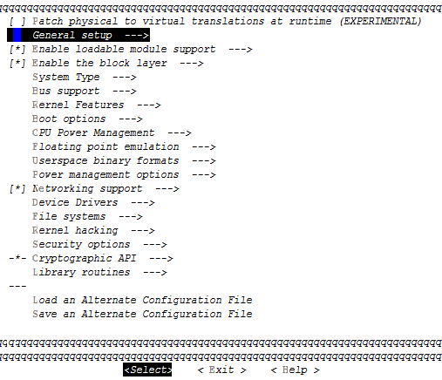

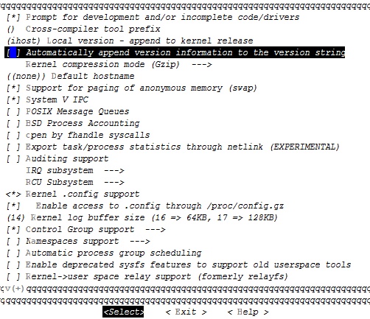

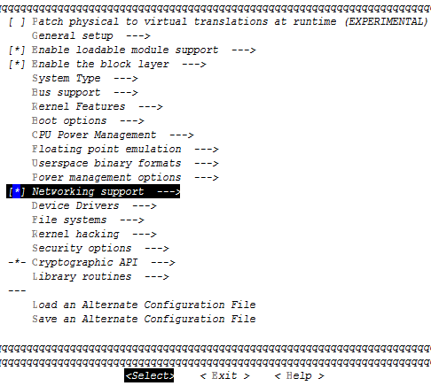

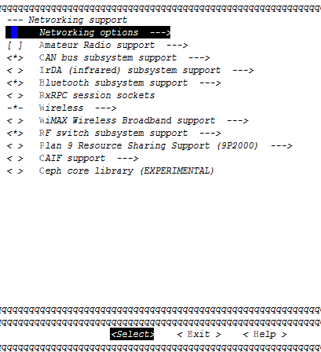

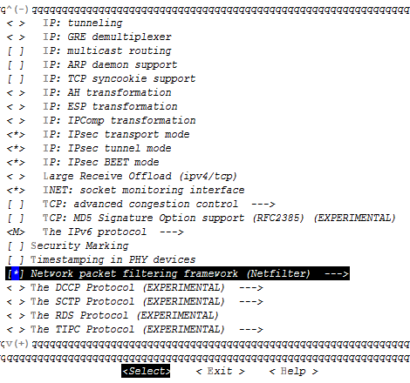

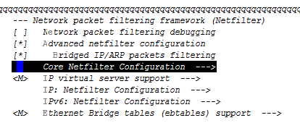

全部选中
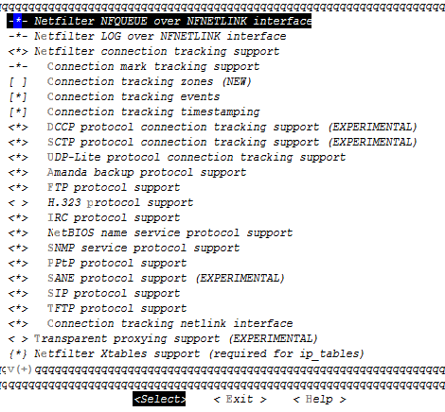

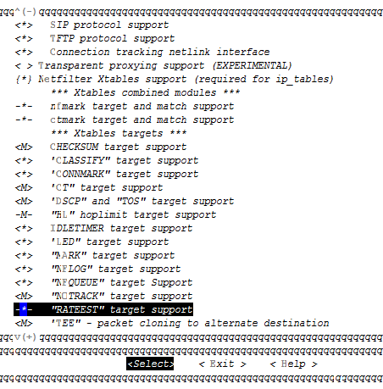

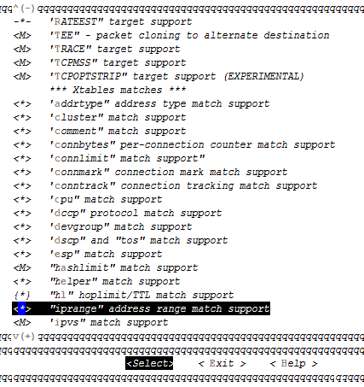

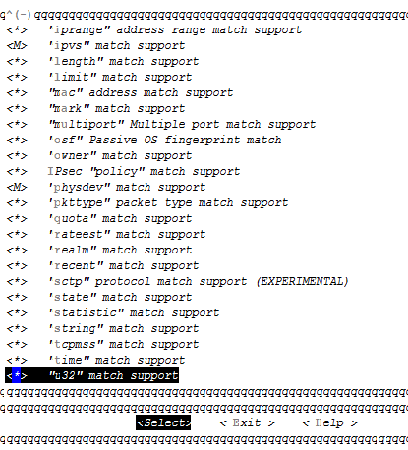

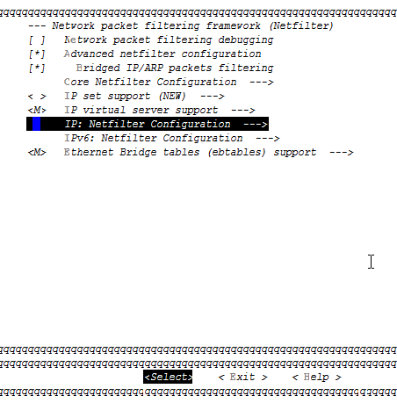

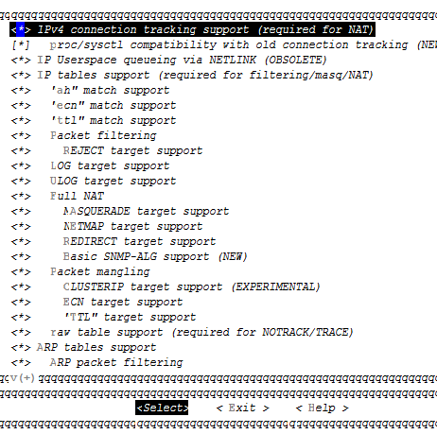

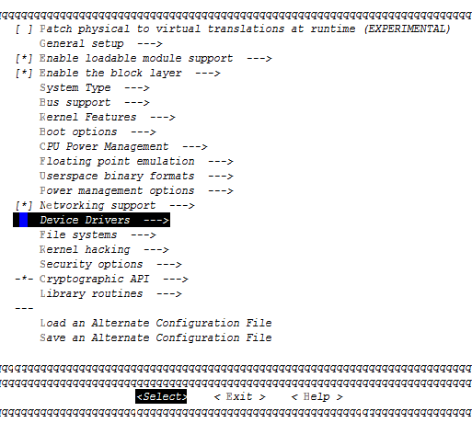

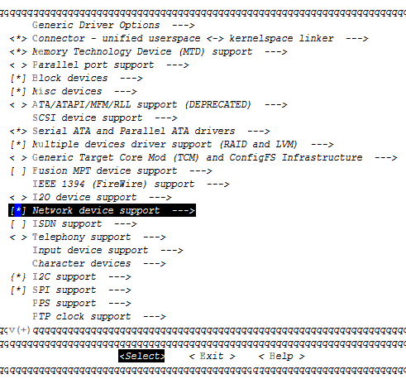

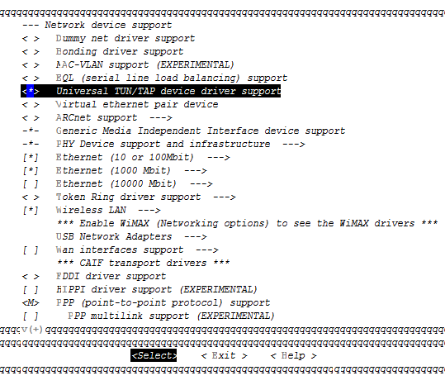
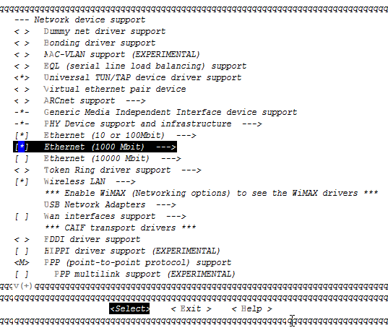

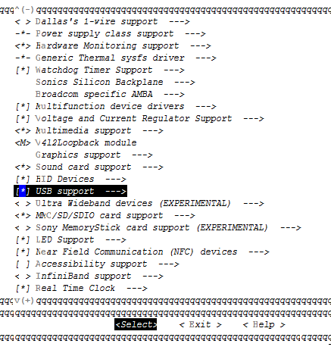

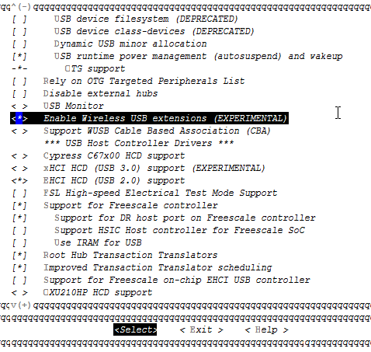

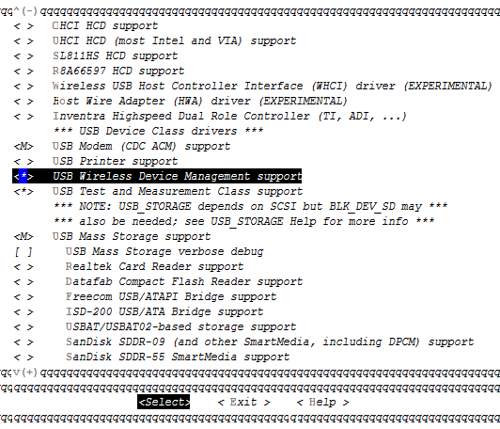

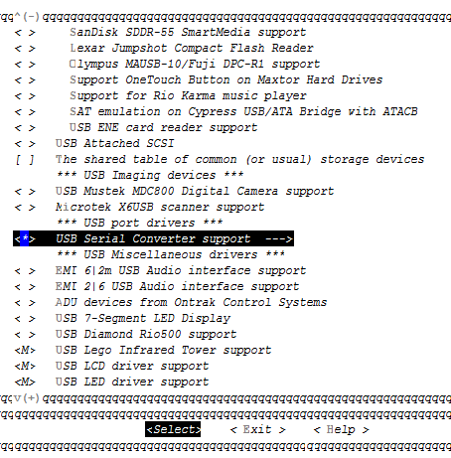

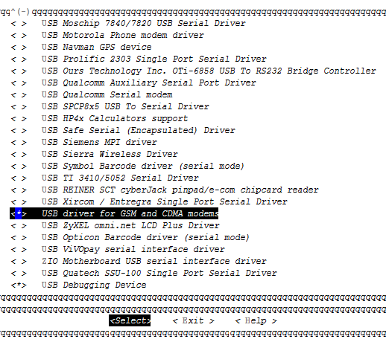

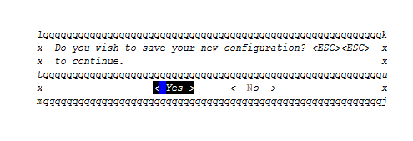

(19:04 root@udoobuntu kernel-ihost) > cd scripts/
(19:04 root@udoobuntu scripts) > ls set* -l
-rwxr-xr-x 1 root root 4.0K Apr 2 17:27 setlocalversion
-rw-r--r-- 1 root root 561 Apr 2 17:27 setsecoversion
(19:04 root@udoobuntu scripts) > chmod +x setsecoversion
(19:04 root@udoobuntu scripts) > ls set* -l
-rwxr-xr-x 1 root root 4.0K Apr 2 17:27 setlocalversion
-rwxr-xr-x 1 root root 561 Apr 2 17:27 setsecoversion
(19:04 root@udoobuntu scripts) > cd ..
(19:04 root@udoobuntu kernel-ihost) >

(19:05 root@udoobuntu kernel-ihost) > nohup make -j5 uImage modules
nohup: ignoring input and appending output to `nohup.out'
(19:37 root@udoobuntu kernel-ihost) >

(19:39 root@udoobuntu 2015-04-02) > cat /usr/src/kernel-ihost/nohup.out | grep uImage
UIMAGE arch/arm/boot/uImage
Image arch/arm/boot/uImage is ready
(19:40 root@udoobuntu 2015-04-02) >

(11:14 root@udoobuntu kernel-ihost) > cp /boot/uImage /boot/uImage.bak
(11:14 root@udoobuntu kernel-ihost) > cp arch/arm/boot/uImage /boot/
cp: overwrite `/boot/uImage'? y
(11:14 root@udoobuntu kernel-ihost) >

(11:15 root@udoobuntu kernel-ihost) > make modules_install

INSTALL sound/core/oss/snd-mixer-oss.ko
INSTALL sound/core/oss/snd-pcm-oss.ko
INSTALL sound/core/seq/oss/snd-seq-oss.ko
INSTALL sound/core/seq/snd-seq-device.ko
INSTALL sound/core/seq/snd-seq-midi-event.ko
INSTALL sound/core/seq/snd-seq-midi.ko
INSTALL sound/core/seq/snd-seq.ko
INSTALL sound/core/snd-hrtimer.ko
INSTALL sound/usb/6fire/snd-usb-6fire.ko
INSTALL sound/usb/caiaq/snd-usb-caiaq.ko
INSTALL sound/usb/misc/snd-ua101.ko
INSTALL /lib/firmware/ttusb-budget/dspbootcode.bin
DEPMOD 3.0.35ihost+
(11:15 root@udoobuntu kernel-ihost) >

(11:15 root@udoobuntu kernel-ihost) > mv /usr/include/linux /usr/include/linux.bak
(11:17 root@udoobuntu kernel-ihost) > cp -r /usr/src/kernel-ihost/include/linux /usr/include/linux
(11:17 root@udoobuntu kernel-ihost) > reboot

(11:19 root@ihost ~) > uname -r
3.0.35ihost+
(11:19 root@ihost ~) >

# common
(11:35 root@ihost ~) > apt-get install -y mysql-server python-mysqldb python-pexpect dos2unix
root 0ffs4t?
# sniffer
(11:41 root@ihost ~) > apt-get install tshark iw
#for winpcap complie
(11:42 root@ihost ~) > apt-get install libpcap-dev flex bison

# sms
(11:47 root@ihost ~) > apt-get install gammu python-gammu
# coova
(11:50 root@ihost ~) > apt-get install debhelper libssl-dev libcurl4-gnutls-dev
# dns
(11:54 root@ihost ~) > apt-get install -y dnsmasq dnsutils
dnsmasq: failed to create listening socket for port 53: Address already in use
...fail!
invoke-rc.d: initscript dnsmasq, action "start" failed.
(11:55 root@ihost ~) >

# curl client for python,
(09:39 root@ihost ~) > apt-get install -y libgtk2.0-dev python-requests
# get network interfaces from python
(09:39 root@ihost ~) > apt-get install -y python-netifaces

# reserved
(09:42 root@ihost ~) > apt-get install -y hostapd
(11:55 root@ihost ~) > apt-get install vlan

(12:23 root@ihost src) > wget http://ap.coova.org/chilli/coova-chilli-1.3.0.tar.gz
(12:23 root@ihost src) > tar xzf coova-chilli-1.3.0.tar.gz
(12:24 root@ihost src) > cd coova-chilli-1.3.0/
(12:24 root@ihost coova-chilli-1.3.0) >

(12:24 root@ihost coova-chilli-1.3.0) > ./configure --prefix=/usr --mandir=\$${prefix}/share/man --infodir=\$${prefix}/share/info \
> --sysconfdir=/etc --localstatedir=/var --enable-largelimits \
> --enable-binstatusfile --enable-statusfile --enable-chilliproxy \
> --enable-chilliradsec --enable-chilliredir --with-openssl --with-curl \
> --with-poll --enable-dhcpopt --enable-sessgarden --enable-dnslog \
> --enable-ipwhitelist --enable-redirdnsreq --enable-miniconfig \
> --enable-libjson --enable-layer3 --enable-proxyvsa --enable-miniportal \
> --enable-chilliscript --enable-eapol --enable-uamdomainfile \
> --enable-modules --enable-multiroute

./configure --prefix=/usr --mandir=\$${prefix}/share/man --infodir=\$${prefix}/share/info \
--sysconfdir=/etc --localstatedir=/var --enable-largelimits \
--enable-binstatusfile --enable-statusfile --enable-chilliproxy \
--enable-chilliradsec --enable-chilliredir --with-openssl --with-curl \
--with-poll --enable-dhcpopt --enable-sessgarden --enable-dnslog \
--enable-ipwhitelist --enable-redirdnsreq --enable-miniconfig \
--enable-libjson --enable-layer3 --enable-proxyvsa --enable-miniportal \
--enable-chilliscript --enable-eapol --enable-uamdomainfile \
--enable-modules --enable-multiroute

(12:34 root@ihost coova-chilli-1.3.0) > echo 9 > debian/compat
(12:34 root@ihost coova-chilli-1.3.0) > nano /usr/src/coova-chilli-1.3.0/debian/rules
install: build
dh_testdir
dh_testroot
dh_clean -k
dh_prep
dh_installdirs
$(MAKE) DESTDIR=/ install
# $(MAKE) DESTDIR=$(CURDIR)/debian/tmp install

NOTICE THE TAB BEFOR STRING, NOT SPACE.OTHERWISE /WWW NO SUCH FILE OR DIRECTORY
NOTICE COPY & PASTE MAKES SPACE INSTEAD OF TAB

(12:37 root@ihost coova-chilli-1.3.0) > mv /usr/include/linux /usr/include/linux.bak.new
(12:39 root@ihost coova-chilli-1.3.0) > mv /usr/include/linux.bak /usr/include/linux

(12:36 root@ihost coova-chilli-1.3.0) > dpkg-buildpackage -us -uc

dpkg-deb: building package `coova-chilli' in `../coova-chilli_1.3.0_armhf.deb'.
dpkg-genchanges >../coova-chilli_1.3.0_armhf.changes
dpkg-genchanges: including full source code in upload
dpkg-source --after-build coova-chilli-1.3.0
dpkg-buildpackage: full upload; Debian-native package (full source is included)
(12:46 root@ihost coova-chilli-1.3.0) >

(12:47 root@ihost coova-chilli-1.3.0) > cd ..
(12:50 root@ihost src) > dpkg -i coova-chilli_1.3.0_armhf.deb
Selecting previously unselected package coova-chilli.
(Reading database ... 99920 files and directories currently installed.)
Unpacking coova-chilli (from coova-chilli_1.3.0_armhf.deb) ...
Setting up coova-chilli (1.3.0) ...

Configuration file `/etc/init.d/chilli'
==> File on system created by you or by a script.
==> File also in package provided by package maintainer.
What would you like to do about it ? Your options are:
Y or I : install the package maintainer's version
N or O : keep your currently-installed version
D : show the differences between the versions
Z : start a shell to examine the situation
The default action is to keep your current version.
*** chilli (Y/I/N/O/D/Z) [default=N] ?
Starting chilli: SIOCSIFADDR: No such device
eth1: ERROR while getting interface flags: No such device

Processing triggers for ureadahead ...
(12:52 root@ihost src) >

(12:37 root@ihost coova-chilli-1.3.0) > mv /usr/include/linux /usr/include/linux.bak
(12:39 root@ihost coova-chilli-1.3.0) > mv /usr/include/linux.bak.new /usr/include/linux

(12:55 root@ihost src) > wget http://downloads.sourceforge.net/project/haserl/haserl-devel/haserl-0.9.30.tar.gz

(12:55 root@ihost src) > tar xzf haserl-0.9.30.tar.gz
(12:55 root@ihost src) > cd haserl-0.9.30/
(12:55 root@ihost haserl-0.9.30) > ./configure
(12:56 root@ihost haserl-0.9.30) > make && make install

(13:05 root@ihost src) > wget http://www.winpcap.org/archive/4.1.1-WpcapSrc.zip
(13:13 root@ihost src) > unzip -a 4.1.1-WpcapSrc.zip
(13:13 root@ihost src) > cd winpcap/wpcap/libpcap
(13:14 root@ihost libpcap) > chmod 755 confi*
(13:14 root@ihost libpcap) > chmod 755 runlex.sh
(13:14 root@ihost libpcap) > ./configure
(13:15 root@ihost libpcap) > make shared

lib的生成位置
(13:17 root@ihost libpcap) > ls libpcap.so.* -l
-rwxr-xr-x 1 root root 196K Apr 4 13:17 libpcap.so.1.0.0
lib的工作位置
(13:18 root@ihost libpcap) > ls /usr/lib/arm-linux-gnueabihf/libpcap* -l
-rw-r--r-- 1 root root 207K Nov 29 2011 /usr/lib/arm-linux-gnueabihf/libpcap.a
lrwxrwxrwx 1 root root 14 Nov 29 2011 /usr/lib/arm-linux-gnueabihf/libpcap.so -> libpcap.so.0.8
lrwxrwxrwx 1 root root 16 Nov 29 2011 /usr/lib/arm-linux-gnueabihf/libpcap.so.0.8 -> libpcap.so.1.1.1
-rw-r--r-- 1 root root 155K Nov 29 2011 /usr/lib/arm-linux-gnueabihf/libpcap.so.1.1.1
(13:20 root@ihost libpcap) >
lib的安装位置
(13:20 root@ihost libpcap) > ls /usr/local/lib/libpcap* -l
ls: cannot access /usr/local/lib/libpcap*: No such file or directory
(13:21 root@ihost libpcap) >

(13:21 root@ihost libpcap) > make install-shared
gcc -shared -Wl,-soname,libpcap.so.1 -o libpcap.so.`cat ./VERSION` pcap-linux.o pcap-usb-linux.o fad-getad.o pcap.o inet.o gencode.o optimize.o nametoaddr.o etherent.o savefile.o bpf_filter.o bpf_image.o bpf_dump.o scanner.o grammar.o version.o pcap-new.o pcap-remote.o sockutils.o
/usr/bin/install -c libpcap.so.`cat VERSION` /usr/local/lib/libpcap.so.`cat VERSION`
(13:22 root@ihost libpcap) >

(13:23 root@ihost libpcap) > ls /usr/local/lib/libpcap* -l
-rwxr-xr-x 1 root root 196K Apr 4 13:22 /usr/local/lib/libpcap.so.1.0.0
(13:23 root@ihost libpcap) > ls /usr/lib/arm-linux-gnueabihf/libpcap* -l
-rw-r--r-- 1 root root 207K Nov 29 2011 /usr/lib/arm-linux-gnueabihf/libpcap.a
lrwxrwxrwx 1 root root 14 Nov 29 2011 /usr/lib/arm-linux-gnueabihf/libpcap.so -> libpcap.so.0.8
lrwxrwxrwx 1 root root 16 Nov 29 2011 /usr/lib/arm-linux-gnueabihf/libpcap.so.0.8 -> libpcap.so.1.1.1
-rw-r--r-- 1 root root 155K Nov 29 2011 /usr/lib/arm-linux-gnueabihf/libpcap.so.1.1.1
(13:23 root@ihost libpcap) >

----------------lib切换--------------------
mv /usr/lib/arm-linux-gnueabihf/libpcap.so.0.8 /usr/lib/arm-linux-gnueabihf/libpcap.so.0.8.bak
ln -sf /usr/local/lib/libpcap.so.1.0.0 /usr/lib/arm-linux-gnueabihf/libpcap.so.0.8
##
rm /usr/lib/arm-linux-gnueabihf/libpcap.so.0.8
mv /usr/lib/arm-linux-gnueabihf/libpcap.so.0.8.bak /usr/lib/arm-linux-gnueabihf/libpcap.so.0.8

(13:30 root@ihost libpcap) > mv /usr/lib/arm-linux-gnueabihf/libpcap.so.0.8 /usr/lib/arm-linux-gnueabihf/libpcap.so.0.8.bak
(13:31 root@ihost libpcap) > ln -sf /usr/local/lib/libpcap.so.1.0.0 /usr/lib/arm-linux-gnueabihf/libpcap.so.0.8
(13:32 root@ihost libpcap) > ls /usr/lib/arm-linux-gnueabihf/libpcap* -l
-rw-r--r-- 1 root root 207K Nov 29 2011 /usr/lib/arm-linux-gnueabihf/libpcap.a
lrwxrwxrwx 1 root root 14 Nov 29 2011 /usr/lib/arm-linux-gnueabihf/libpcap.so -> libpcap.so.0.8
lrwxrwxrwx 1 root root 31 Apr 4 13:32 /usr/lib/arm-linux-gnueabihf/libpcap.so.0.8 -> /usr/local/lib/libpcap.so.1.0.0
lrwxrwxrwx 1 root root 16 Nov 29 2011 /usr/lib/arm-linux-gnueabihf/libpcap.so.0.8.bak -> libpcap.so.1.1.1
-rw-r--r-- 1 root root 155K Nov 29 2011 /usr/lib/arm-linux-gnueabihf/libpcap.so.1.1.1
(13:32 root@ihost libpcap) > tshark -i rpcap://192.168.1.136/wlan100
tshark: Lua: Error during loading:
[string "/usr/share/wireshark/init.lua"]:45: dofile has been disabled
Running as user "root" and group "root". This could be dangerous.
Capturing on rpcap://192.168.1.136/wlan100
tshark: The capture session could not be initiated (Is the server properly installed on 192.168.1.136? connect() failed: No route to host (code 113) ).
Please check to make sure you have sufficient permissions, and that you have the proper interface or pipe specified.
0 packets captured
(13:32 root@ihost libpcap) > tshark -i eth0 -c 5
tshark: Lua: Error during loading:
[string "/usr/share/wireshark/init.lua"]:45: dofile has been disabled
Running as user "root" and group "root". This could be dangerous.
Capturing on eth0

# insserv fix
ln -sf /usr/lib/insserv/insserv /sbin/insserv

# 安装java 8
1,在无线路由器上为ihost分配静态ip地址：192.168.1.7

2,安装java 8
root@radxa:~# java -version
The program 'java' can be found in the following packages:
* default-jre
* gcj-4.8-jre-headless
* openjdk-7-jre-headless
* gcj-4.6-jre-headless
* openjdk-6-jre-headless
Try: apt-get install <selected package>
root@radxa:~#

http://www.rpiblog.com/2014/03/installing-oracle-jdk-8-on-raspberry-pi.html

root@radxa:~# scp -P 2708 wlsp@182.92.195.40:/home/wlsp/jdk-8u33-linux-arm-vfp-hflt.gz ./

root@radxa:~# tar zxvf jdk-8u33-linux-arm-vfp-hflt.gz -C /opt

root@radxa:~# update-alternatives --install /usr/bin/javac javac /opt/jdk1.8.0_33/bin/javac 1
update-alternatives: using /opt/jdk1.8.0_33/bin/javac to provide /usr/bin/javac (javac) in auto mode
root@radxa:~#

root@radxa:~# update-alternatives --install /usr/bin/java java /opt/jdk1.8.0_33/bin/java 1
update-alternatives: using /opt/jdk1.8.0_33/bin/java to provide /usr/bin/java (java) in auto mode
root@radxa:~#

root@radxa:~# update-alternatives --config javac
There is only one alternative in link group javac (providing /usr/bin/javac): /opt/jdk1.8.0_33/bin/javac
Nothing to configure.
root@radxa:~#
root@radxa:~# update-alternatives --config java
There is only one alternative in link group java (providing /usr/bin/java): /opt/jdk1.8.0_33/bin/java
Nothing to configure.
root@radxa:~#

root@radxa:~# java -version
java version "1.8.0_33"
Java(TM) SE Runtime Environment (build 1.8.0_33-b05)
Java HotSpot(TM) Client VM (build 25.33-b05, mixed mode)
root@radxa:~# javac -version
javac 1.8.0_33
root@radxa:~#

root@radxa:~# echo $JAVA_HOME

root@radxa:~#

root@radxa:~# set JAVA_HOME=/opt/jdk1.8.0_33/
root@radxa:~# echo $JAVA_HOME

root@radxa:~#

3,下载wms.war

root@radxa:~# scp -P 2708 wlsp@182.92.195.40:/home/wlsp/wms.war ./
The authenticity of host '[182.92.195.40]:2708 ([182.92.195.40]:2708)' can't be established.
ECDSA key fingerprint is 55:84:03:9e:d9:74:cc:cd:03:59:23:3f:df:d9:77:a5.
Are you sure you want to continue connecting (yes/no)? yes
Warning: Permanently added '[182.92.195.40]:2708' (ECDSA) to the list of known hosts.
wlsp@182.92.195.40's password:
wms.war 100% 27MB 272.7KB/s 01:42
root@radxa:~#

java -jar wms.war

root@radxa:~# tshark -i eth0 -f 'udp and ether host 00:73:e0:67:42:e2'

root@radxa:~# tshark -i eth0 -f 'udp and ether host 00:16:6d:c0:76:3c'

tshark -i wlan0 -f 'udp and ether host 00:73:e0:67:42:e2'

nohup.out

modules:

LD [M] crypto/async_tx/async_memcpy.ko
LD [M] crypto/async_tx/async_pq.ko
LD [M] crypto/async_tx/async_raid6_recov.ko
LD [M] crypto/async_tx/async_tx.ko
LD [M] crypto/async_tx/async_xor.ko
LD [M] crypto/hmac.ko
LD [M] crypto/md4.ko
LD [M] crypto/md5.ko
LD [M] crypto/tcrypt.ko
LD [M] crypto/xor.ko
LD [M] drivers/bluetooth/ath3k.ko
LD [M] drivers/bluetooth/bcm203x.ko
LD [M] drivers/bluetooth/bpa10x.ko
LD [M] drivers/bluetooth/bfusb.ko
LD [M] drivers/bluetooth/btmrvl.ko
LD [M] drivers/bluetooth/btmrvl_sdio.ko
LD [M] drivers/gpu/drm/drm.ko
LD [M] drivers/bluetooth/btsdio.ko
LD [M] drivers/gpu/drm/vivante/vivante.ko
LD [M] drivers/hid/hid-a4tech.ko
LD [M] drivers/hid/hid-belkin.ko
LD [M] drivers/hid/hid-apple.ko
LD [M] drivers/hid/hid-cherry.ko
LD [M] drivers/hid/hid-chicony.ko
LD [M] drivers/hid/hid-ezkey.ko
LD [M] drivers/hid/hid-cypress.ko
LD [M] drivers/hid/hid-gyration.ko
LD [M] drivers/hid/hid-keytouch.ko
LD [M] drivers/hid/hid-logitech.ko
LD [M] drivers/hid/hid-magicmouse.ko
LD [M] drivers/hid/hid-microsoft.ko
LD [M] drivers/hid/hid-monterey.ko
LD [M] drivers/hid/hid-multitouch.ko
LD [M] drivers/hid/hid-petalynx.ko
LD [M] drivers/hid/hid-pl.ko
LD [M] drivers/hid/hid-samsung.ko
LD [M] drivers/hid/hid-sjoy.ko
LD [M] drivers/hid/hid-sony.ko
LD [M] drivers/hid/hid-sunplus.ko
LD [M] drivers/hid/hid-tmff.ko
LD [M] drivers/i2c/algos/i2c-algo-bit.ko
LD [M] drivers/input/ff-memless.ko
LD [M] drivers/input/joydev.ko
LD [M] drivers/input/gameport/gameport.ko
LD [M] drivers/input/joystick/adi.ko
LD [M] drivers/input/joystick/analog.ko
LD [M] drivers/input/joystick/sidewinder.ko
LD [M] drivers/input/joystick/xpad.ko
LD [M] drivers/input/misc/rotary_encoder.ko
LD [M] drivers/input/misc/isl29023.ko
LD [M] drivers/input/mouse/appletouch.ko
LD [M] drivers/input/mouse/bcm5974.ko
LD [M] drivers/input/tablet/wacom.ko
LD [M] drivers/md/dm-crypt.ko
LD [M] drivers/md/dm-log.ko
LD [M] drivers/md/dm-mirror.ko
LD [M] drivers/md/dm-mod.ko
LD [M] drivers/md/dm-raid.ko
LD [M] drivers/md/dm-multipath.ko
LD [M] drivers/md/dm-region-hash.ko
LD [M] drivers/md/dm-round-robin.ko
LD [M] drivers/md/dm-snapshot.ko
LD [M] drivers/md/faulty.ko
LD [M] drivers/md/linear.ko
LD [M] drivers/md/md-mod.ko
LD [M] drivers/md/multipath.ko
LD [M] drivers/md/raid0.ko
LD [M] drivers/md/raid1.ko
LD [M] drivers/md/raid10.ko
LD [M] drivers/md/raid456.ko
LD [M] drivers/media/common/tuners/max2165.ko
LD [M] drivers/media/common/tuners/mt2060.ko
LD [M] drivers/media/common/tuners/mt2131.ko
LD [M] drivers/media/common/tuners/mt2266.ko
LD [M] drivers/media/common/tuners/mxl5005s.ko
LD [M] drivers/media/common/tuners/mxl5007t.ko
LD [M] drivers/media/common/tuners/qt1010.ko
LD [M] drivers/media/common/tuners/tda18212.ko
LD [M] drivers/media/common/tuners/tda18218.ko
LD [M] drivers/media/dvb/b2c2/b2c2-flexcop.ko
LD [M] drivers/media/dvb/dvb-usb/dvb-usb-a800.ko
LD [M] drivers/media/dvb/dvb-usb/dvb-usb-af9005-remote.ko
LD [M] drivers/media/dvb/dvb-usb/dvb-usb-af9005.ko
LD [M] drivers/media/dvb/dm1105/dm1105.ko
LD [M] drivers/media/dvb/dvb-usb/dvb-usb-af9015.ko
LD [M] drivers/media/dvb/dvb-usb/dvb-usb-anysee.ko
LD [M] drivers/media/dvb/dvb-usb/dvb-usb-au6610.ko
LD [M] drivers/media/dvb/dvb-usb/dvb-usb-az6027.ko
LD [M] drivers/media/dvb/dvb-usb/dvb-usb-ce6230.ko
LD [M] drivers/media/dvb/dvb-usb/dvb-usb-cinergyT2.ko
LD [M] drivers/media/dvb/dvb-usb/dvb-usb-cxusb.ko
LD [M] drivers/media/dvb/dvb-usb/dvb-usb-dib0700.ko
LD [M] drivers/media/dvb/dvb-usb/dvb-usb-dibusb-common.ko
LD [M] drivers/media/dvb/dvb-usb/dvb-usb-dibusb-mb.ko
LD [M] drivers/media/dvb/dvb-usb/dvb-usb-dibusb-mc.ko
LD [M] drivers/media/dvb/dvb-usb/dvb-usb-digitv.ko
LD [M] drivers/media/dvb/dvb-usb/dvb-usb-dtt200u.ko
LD [M] drivers/media/dvb/dvb-usb/dvb-usb-dtv5100.ko
LD [M] drivers/media/dvb/dvb-usb/dvb-usb-dw2102.ko
LD [M] drivers/media/dvb/dvb-usb/dvb-usb-friio.ko
LD [M] drivers/media/dvb/dvb-usb/dvb-usb-ec168.ko
LD [M] drivers/media/dvb/dvb-usb/dvb-usb-gl861.ko
LD [M] drivers/media/dvb/dvb-usb/dvb-usb-gp8psk.ko
LD [M] drivers/media/dvb/dvb-usb/dvb-usb-m920x.ko
LD [M] drivers/media/dvb/dvb-usb/dvb-usb-lmedm04.ko
LD [M] drivers/media/dvb/dvb-usb/dvb-usb-nova-t-usb2.ko
LD [M] drivers/media/dvb/dvb-usb/dvb-usb-opera.ko
LD [M] drivers/media/dvb/dvb-usb/dvb-usb-technisat-usb2.ko
LD [M] drivers/media/dvb/dvb-usb/dvb-usb-ttusb2.ko
LD [M] drivers/media/dvb/dvb-usb/dvb-usb-vp702x.ko
LD [M] drivers/media/dvb/dvb-usb/dvb-usb-umt-010.ko
LD [M] drivers/media/dvb/dvb-usb/dvb-usb.ko
LD [M] drivers/media/dvb/dvb-usb/dvb-usb-vp7045.ko
LD [M] drivers/media/dvb/mantis/hopper.ko
LD [M] drivers/media/dvb/mantis/mantis.ko
LD [M] drivers/media/dvb/mantis/mantis_core.ko
LD [M] drivers/media/dvb/ngene/ngene.ko
LD [M] drivers/media/dvb/pluto2/pluto2.ko
LD [M] drivers/media/dvb/pt1/earth-pt1.ko
LD [M] drivers/media/dvb/ttusb-dec/ttusb_dec.ko
LD [M] drivers/media/rc/ir-jvc-decoder.ko
LD [M] drivers/media/dvb/ttusb-dec/ttusbdecfe.ko
LD [M] drivers/media/dvb/ttusb-budget/dvb-ttusb-budget.ko
LD [M] drivers/media/rc/ir-lirc-codec.ko
LD [M] drivers/media/rc/ir-nec-decoder.ko
LD [M] drivers/media/rc/ir-rc5-sz-decoder.ko
LD [M] drivers/media/rc/ir-rc5-decoder.ko
LD [M] drivers/media/rc/ir-rc6-decoder.ko
LD [M] drivers/media/rc/ir-sony-decoder.ko
LD [M] drivers/media/rc/keymaps/rc-adstech-dvb-t-pci.ko
LD [M] drivers/media/rc/keymaps/rc-alink-dtu-m.ko
LD [M] drivers/media/rc/keymaps/rc-anysee.ko
LD [M] drivers/media/rc/keymaps/rc-apac-viewcomp.ko
LD [M] drivers/media/rc/keymaps/rc-asus-pc39.ko
LD [M] drivers/media/rc/keymaps/rc-avermedia-a16d.ko
LD [M] drivers/media/rc/keymaps/rc-ati-tv-wonder-hd-600.ko
LD [M] drivers/media/rc/keymaps/rc-avermedia-cardbus.ko
LD [M] drivers/media/rc/keymaps/rc-avermedia-dvbt.ko
LD [M] drivers/media/rc/keymaps/rc-avermedia-m135a.ko
LD [M] drivers/media/rc/keymaps/rc-avermedia-m733a-rm-k6.ko
LD [M] drivers/media/rc/keymaps/rc-avermedia-rm-ks.ko
LD [M] drivers/media/rc/keymaps/rc-avertv-303.ko
LD [M] drivers/media/rc/keymaps/rc-avermedia.ko
LD [M] drivers/media/rc/keymaps/rc-azurewave-ad-tu700.ko
LD [M] drivers/media/rc/keymaps/rc-behold.ko
LD [M] drivers/media/rc/keymaps/rc-budget-ci-old.ko
LD [M] drivers/media/rc/keymaps/rc-behold-columbus.ko
LD [M] drivers/media/rc/keymaps/rc-cinergy-1400.ko
LD [M] drivers/media/rc/keymaps/rc-cinergy.ko
LD [M] drivers/media/rc/keymaps/rc-dib0700-nec.ko
LD [M] drivers/media/rc/keymaps/rc-dib0700-rc5.ko
LD [M] drivers/media/rc/keymaps/rc-digitalnow-tinytwin.ko
LD [M] drivers/media/rc/keymaps/rc-digittrade.ko
LD [M] drivers/media/rc/keymaps/rc-dm1105-nec.ko
LD [M] drivers/media/rc/keymaps/rc-dntv-live-dvb-t.ko
LD [M] drivers/media/rc/keymaps/rc-dntv-live-dvbt-pro.ko
LD [M] drivers/media/rc/keymaps/rc-em-terratec.ko
LD [M] drivers/media/rc/keymaps/rc-encore-enltv.ko
LD [M] drivers/media/rc/keymaps/rc-encore-enltv-fm53.ko
LD [M] drivers/media/rc/keymaps/rc-encore-enltv2.ko
LD [M] drivers/media/rc/keymaps/rc-evga-indtube.ko
LD [M] drivers/media/rc/keymaps/rc-eztv.ko
LD [M] drivers/media/rc/keymaps/rc-flydvb.ko
LD [M] drivers/media/rc/keymaps/rc-flyvideo.ko
LD [M] drivers/media/rc/keymaps/rc-fusionhdtv-mce.ko
LD [M] drivers/media/rc/keymaps/rc-gadmei-rm008z.ko
LD [M] drivers/media/rc/keymaps/rc-genius-tvgo-a11mce.ko
LD [M] drivers/media/rc/keymaps/rc-gotview7135.ko
LD [M] drivers/media/rc/keymaps/rc-hauppauge.ko
LD [M] drivers/media/rc/keymaps/rc-imon-mce.ko
LD [M] drivers/media/rc/keymaps/rc-imon-pad.ko
LD [M] drivers/media/rc/keymaps/rc-iodata-bctv7e.ko
LD [M] drivers/media/rc/keymaps/rc-kworld-315u.ko
LD [M] drivers/media/rc/keymaps/rc-kaiomy.ko
LD [M] drivers/media/rc/keymaps/rc-leadtek-y04g0051.ko
LD [M] drivers/media/rc/keymaps/rc-kworld-plus-tv-analog.ko
LD [M] drivers/media/rc/keymaps/rc-lirc.ko
LD [M] drivers/media/rc/keymaps/rc-lme2510.ko
LD [M] drivers/media/rc/keymaps/rc-manli.ko
LD [M] drivers/media/rc/keymaps/rc-msi-digivox-ii.ko
LD [M] drivers/media/rc/keymaps/rc-msi-digivox-iii.ko
LD [M] drivers/media/rc/keymaps/rc-msi-tvanywhere.ko
LD [M] drivers/media/rc/keymaps/rc-msi-tvanywhere-plus.ko
LD [M] drivers/media/rc/keymaps/rc-nebula.ko
LD [M] drivers/media/rc/keymaps/rc-nec-terratec-cinergy-xs.ko
LD [M] drivers/media/rc/keymaps/rc-npgtech.ko
LD [M] drivers/media/rc/keymaps/rc-norwood.ko
LD [M] drivers/media/rc/keymaps/rc-pctv-sedna.ko
LD [M] drivers/media/rc/keymaps/rc-pinnacle-grey.ko
LD [M] drivers/media/rc/keymaps/rc-pinnacle-color.ko
LD [M] drivers/media/rc/keymaps/rc-pinnacle-pctv-hd.ko
LD [M] drivers/media/rc/keymaps/rc-pixelview-002t.ko
LD [M] drivers/media/rc/keymaps/rc-pixelview-new.ko
LD [M] drivers/media/rc/keymaps/rc-pixelview-mk12.ko
LD [M] drivers/media/rc/keymaps/rc-pixelview.ko
LD [M] drivers/media/rc/keymaps/rc-powercolor-real-angel.ko
LD [M] drivers/media/rc/keymaps/rc-proteus-2309.ko
LD [M] drivers/media/rc/keymaps/rc-pv951.ko
LD [M] drivers/media/rc/keymaps/rc-rc6-mce.ko
LD [M] drivers/media/rc/keymaps/rc-purpletv.ko
LD [M] drivers/media/rc/keymaps/rc-real-audio-220-32-keys.ko
LD [M] drivers/media/rc/keymaps/rc-streamzap.ko
LD [M] drivers/media/rc/keymaps/rc-technisat-usb2.ko
LD [M] drivers/media/rc/keymaps/rc-terratec-cinergy-xs.ko
LD [M] drivers/media/rc/keymaps/rc-terratec-slim.ko
LD [M] drivers/media/rc/keymaps/rc-tbs-nec.ko
LD [M] drivers/media/rc/keymaps/rc-terratec-slim-2.ko
LD [M] drivers/media/rc/keymaps/rc-tevii-nec.ko
LD [M] drivers/media/rc/keymaps/rc-tivo.ko
LD [M] drivers/media/rc/keymaps/rc-total-media-in-hand.ko
LD [M] drivers/media/rc/keymaps/rc-trekstor.ko
LD [M] drivers/media/rc/keymaps/rc-tt-1500.ko
LD [M] drivers/media/rc/keymaps/rc-twinhan1027.ko
LD [M] drivers/media/rc/keymaps/rc-videomate-m1f.ko
LD [M] drivers/media/rc/keymaps/rc-videomate-s350.ko
LD [M] drivers/media/rc/keymaps/rc-videomate-tv-pvr.ko
LD [M] drivers/media/rc/keymaps/rc-winfast-usbii-deluxe.ko
LD [M] drivers/media/rc/keymaps/rc-winfast.ko
LD [M] drivers/media/rc/rc-core.ko
LD [M] drivers/media/rc/lirc_dev.ko
LD [M] drivers/media/video/cs53l32a.ko
LD [M] drivers/media/video/cx231xx/cx231xx.ko
LD [M] drivers/media/video/cx2341x.ko
LD [M] drivers/media/video/cx25840/cx25840.ko
LD [M] drivers/media/video/em28xx/em28xx.ko
LD [M] drivers/media/video/gspca/gspca_kinect.ko
LD [M] drivers/media/video/gspca/gspca_ov519.ko
LD [M] drivers/media/video/gspca/gspca_main.ko
LD [M] drivers/media/video/gspca/gspca_ov534.ko
LD [M] drivers/media/video/gspca/gspca_ov534_9.ko
LD [M] drivers/media/video/hdpvr/hdpvr.ko
LD [M] drivers/media/video/ir-kbd-i2c.ko
LD [M] drivers/media/video/mem2mem_testdev.ko
LD [M] drivers/media/video/msp3400.ko
LD [M] drivers/media/video/pvrusb2/pvrusb2.ko
LD [M] drivers/media/video/pwc/pwc.ko
LD [M] drivers/media/video/s2255drv.ko
LD [M] drivers/media/video/saa7115.ko
LD [M] drivers/media/video/tlg2300/poseidon.ko
LD [M] drivers/media/video/stkwebcam.ko
LD [M] drivers/media/video/tveeprom.ko
LD [M] drivers/media/video/tuner.ko
LD [M] drivers/media/video/v4l2-mem2mem.ko
LD [M] drivers/media/video/videobuf-dvb.ko
LD [M] drivers/media/video/usbvision/usbvision.ko
LD [M] drivers/media/video/wm8775.ko
LD [M] drivers/media/video/videobuf-vmalloc.ko
LD [M] drivers/media/video/zr364xx.ko
LD [M] drivers/mxc/dam/dam.ko
LD [M] drivers/mxc/hdmi-cec/mxc_hdmi-cec.ko
LD [M] drivers/net/ppp_async.ko
LD [M] drivers/net/ppp_generic.ko
LD [M] drivers/net/slhc.ko
LD [M] drivers/net/wireless/ath/ath.ko
LD [M] drivers/net/wireless/ath/ath6kl/ath6kl.ko
LD [M] drivers/nfc/pn544.ko
LD [M] drivers/scsi/scsi_wait_scan.ko
LD [M] drivers/uio/uio.ko
LD [M] drivers/usb/class/cdc-acm.ko
LD [M] drivers/usb/misc/trancevibrator.ko
LD [M] drivers/usb/misc/legousbtower.ko
LD [M] drivers/usb/misc/usblcd.ko
LD [M] drivers/usb/misc/usbled.ko
LD [M] drivers/usb/serial/cp210x.ko
LD [M] drivers/usb/serial/ipw.ko
LD [M] drivers/usb/serial/ftdi_sio.ko
LD [M] drivers/video/v4l2loopback.ko
LD [M] fs/cifs/cifs.ko
LD [M] drivers/usb/storage/usb-storage.ko
LD [M] fs/exportfs/exportfs.ko
LD [M] fs/isofs/isofs.ko
LD [M] fs/jfs/jfs.ko
LD [M] fs/nfsd/nfsd.ko
LD [M] fs/nls/nls_ascii.ko
LD [M] fs/nls/nls_utf8.ko
LD [M] fs/ntfs/ntfs.ko
LD [M] fs/udf/udf.ko
LD [M] fs/xfs/xfs.ko
LD [M] lib/crc-itu-t.ko
LD [M] lib/raid6/raid6_pq.ko
LD [M] net/802/stp.ko
LD [M] net/batman-adv/batman-adv.ko
LD [M] net/bridge/bridge.ko
LD [M] net/bridge/netfilter/ebt_802_3.ko
LD [M] net/bridge/netfilter/ebt_arp.ko
LD [M] net/bridge/netfilter/ebt_among.ko
LD [M] net/bridge/netfilter/ebt_arpreply.ko
LD [M] net/bridge/netfilter/ebt_dnat.ko
LD [M] net/bridge/netfilter/ebt_ip.ko
LD [M] net/bridge/netfilter/ebt_ip6.ko
LD [M] net/bridge/netfilter/ebt_limit.ko
LD [M] net/bridge/netfilter/ebt_log.ko
LD [M] net/bridge/netfilter/ebt_mark.ko
LD [M] net/bridge/netfilter/ebt_mark_m.ko
LD [M] net/bridge/netfilter/ebt_nflog.ko
LD [M] net/bridge/netfilter/ebt_redirect.ko
LD [M] net/bridge/netfilter/ebt_pkttype.ko
LD [M] net/bridge/netfilter/ebt_snat.ko
LD [M] net/bridge/netfilter/ebt_stp.ko
LD [M] net/bridge/netfilter/ebt_ulog.ko
LD [M] net/bridge/netfilter/ebt_vlan.ko
LD [M] net/bridge/netfilter/ebtable_broute.ko
LD [M] net/bridge/netfilter/ebtable_filter.ko
LD [M] net/bridge/netfilter/ebtable_nat.ko
LD [M] net/bridge/netfilter/ebtables.ko
LD [M] net/ipv4/netfilter/nf_nat_h323.ko
LD [M] net/ipv4/tunnel4.ko
LD [M] net/ipv6/ipv6.ko
LD [M] net/ipv6/netfilter/ip6_tables.ko
LD [M] net/ipv6/netfilter/ip6t_LOG.ko
LD [M] net/ipv6/netfilter/ip6t_REJECT.ko
LD [M] net/ipv6/netfilter/ip6t_ah.ko
LD [M] net/ipv6/netfilter/ip6t_eui64.ko
LD [M] net/ipv6/netfilter/ip6t_frag.ko
LD [M] net/ipv6/netfilter/ip6t_hbh.ko
LD [M] net/ipv6/netfilter/ip6t_ipv6header.ko
LD [M] net/ipv6/netfilter/ip6t_mh.ko
LD [M] net/ipv6/netfilter/ip6t_rt.ko
LD [M] net/ipv6/netfilter/ip6table_filter.ko
LD [M] net/ipv6/netfilter/ip6table_mangle.ko
LD [M] net/ipv6/netfilter/ip6table_raw.ko
LD [M] net/ipv6/netfilter/nf_defrag_ipv6.ko
LD [M] net/ipv6/sit.ko
LD [M] net/ipv6/xfrm6_mode_beet.ko
LD [M] net/ipv6/xfrm6_mode_transport.ko
LD [M] net/ipv6/xfrm6_mode_tunnel.ko
LD [M] net/netfilter/ipvs/ip_vs.ko
LD [M] net/netfilter/nf_conntrack_h323.ko
LD [M] net/netfilter/nf_tproxy_core.ko
LD [M] net/netfilter/xt_CT.ko
LD [M] net/netfilter/xt_CHECKSUM.ko
LD [M] net/netfilter/xt_NOTRACK.ko
LD [M] net/netfilter/xt_DSCP.ko
LD [M] net/netfilter/xt_TCPOPTSTRIP.ko
LD [M] net/netfilter/xt_TEE.ko
LD [M] net/netfilter/xt_TCPMSS.ko
LD [M] net/netfilter/xt_TPROXY.ko
LD [M] net/netfilter/xt_TRACE.ko
LD [M] net/netfilter/xt_ipvs.ko
LD [M] net/netfilter/xt_physdev.ko
LD [M] net/netfilter/xt_hashlimit.ko
LD [M] net/netfilter/xt_socket.ko
LD [M] sound/core/oss/snd-mixer-oss.ko
LD [M] sound/core/seq/oss/snd-seq-oss.ko
LD [M] sound/core/oss/snd-pcm-oss.ko
LD [M] sound/core/seq/snd-seq-device.ko
LD [M] sound/core/seq/snd-seq-midi-event.ko
LD [M] sound/core/seq/snd-seq-midi.ko
LD [M] sound/core/snd-hrtimer.ko
LD [M] sound/core/seq/snd-seq.ko
LD [M] sound/usb/6fire/snd-usb-6fire.ko
LD [M] sound/usb/caiaq/snd-usb-caiaq.ko
LD [M] sound/usb/misc/snd-ua101.ko
IHEX firmware/ttusb-budget/dspbootcode.bin

modules install:
INSTALL crypto/async_tx/async_memcpy.ko
INSTALL crypto/async_tx/async_pq.ko
INSTALL crypto/async_tx/async_raid6_recov.ko
INSTALL crypto/async_tx/async_tx.ko
INSTALL crypto/async_tx/async_xor.ko
INSTALL crypto/hmac.ko
INSTALL crypto/md4.ko
INSTALL crypto/md5.ko
INSTALL crypto/tcrypt.ko
INSTALL crypto/xor.ko
INSTALL drivers/bluetooth/ath3k.ko
INSTALL drivers/bluetooth/bcm203x.ko
INSTALL drivers/bluetooth/bfusb.ko
INSTALL drivers/bluetooth/bpa10x.ko
INSTALL drivers/bluetooth/btmrvl.ko
INSTALL drivers/bluetooth/btmrvl_sdio.ko
INSTALL drivers/bluetooth/btsdio.ko
INSTALL drivers/gpu/drm/drm.ko
INSTALL drivers/gpu/drm/vivante/vivante.ko
INSTALL drivers/hid/hid-a4tech.ko
INSTALL drivers/hid/hid-apple.ko
INSTALL drivers/hid/hid-belkin.ko
INSTALL drivers/hid/hid-cherry.ko
INSTALL drivers/hid/hid-chicony.ko
INSTALL drivers/hid/hid-cypress.ko
INSTALL drivers/hid/hid-ezkey.ko
INSTALL drivers/hid/hid-gyration.ko
INSTALL drivers/hid/hid-keytouch.ko
INSTALL drivers/hid/hid-logitech.ko
INSTALL drivers/hid/hid-magicmouse.ko
INSTALL drivers/hid/hid-microsoft.ko
INSTALL drivers/hid/hid-monterey.ko
INSTALL drivers/hid/hid-multitouch.ko
INSTALL drivers/hid/hid-petalynx.ko
INSTALL drivers/hid/hid-pl.ko
INSTALL drivers/hid/hid-samsung.ko
INSTALL drivers/hid/hid-sjoy.ko
INSTALL drivers/hid/hid-sony.ko
INSTALL drivers/hid/hid-sunplus.ko
INSTALL drivers/hid/hid-tmff.ko
INSTALL drivers/i2c/algos/i2c-algo-bit.ko
INSTALL drivers/input/ff-memless.ko
INSTALL drivers/input/gameport/gameport.ko
INSTALL drivers/input/joydev.ko
INSTALL drivers/input/joystick/adi.ko
INSTALL drivers/input/joystick/analog.ko
INSTALL drivers/input/joystick/sidewinder.ko
INSTALL drivers/input/joystick/xpad.ko
INSTALL drivers/input/misc/isl29023.ko
INSTALL drivers/input/misc/rotary_encoder.ko
INSTALL drivers/input/mouse/appletouch.ko
INSTALL drivers/input/mouse/bcm5974.ko
INSTALL drivers/input/tablet/wacom.ko
INSTALL drivers/md/dm-crypt.ko
INSTALL drivers/md/dm-log.ko
INSTALL drivers/md/dm-mirror.ko
INSTALL drivers/md/dm-mod.ko
INSTALL drivers/md/dm-multipath.ko
INSTALL drivers/md/dm-raid.ko
INSTALL drivers/md/dm-region-hash.ko
INSTALL drivers/md/dm-round-robin.ko
INSTALL drivers/md/dm-snapshot.ko
INSTALL drivers/md/faulty.ko
INSTALL drivers/md/linear.ko
INSTALL drivers/md/md-mod.ko
INSTALL drivers/md/multipath.ko
INSTALL drivers/md/raid0.ko
INSTALL drivers/md/raid1.ko
INSTALL drivers/md/raid10.ko
INSTALL drivers/md/raid456.ko
INSTALL drivers/media/common/tuners/max2165.ko
INSTALL drivers/media/common/tuners/mt2060.ko
INSTALL drivers/media/common/tuners/mt2131.ko
INSTALL drivers/media/common/tuners/mt2266.ko
INSTALL drivers/media/common/tuners/mxl5005s.ko
INSTALL drivers/media/common/tuners/mxl5007t.ko
INSTALL drivers/media/common/tuners/qt1010.ko
INSTALL drivers/media/common/tuners/tda18212.ko
INSTALL drivers/media/common/tuners/tda18218.ko
INSTALL drivers/media/dvb/b2c2/b2c2-flexcop.ko
INSTALL drivers/media/dvb/dm1105/dm1105.ko
INSTALL drivers/media/dvb/dvb-usb/dvb-usb-a800.ko
INSTALL drivers/media/dvb/dvb-usb/dvb-usb-af9005-remote.ko
INSTALL drivers/media/dvb/dvb-usb/dvb-usb-af9005.ko
INSTALL drivers/media/dvb/dvb-usb/dvb-usb-af9015.ko
INSTALL drivers/media/dvb/dvb-usb/dvb-usb-anysee.ko
INSTALL drivers/media/dvb/dvb-usb/dvb-usb-au6610.ko
INSTALL drivers/media/dvb/dvb-usb/dvb-usb-az6027.ko
INSTALL drivers/media/dvb/dvb-usb/dvb-usb-ce6230.ko
INSTALL drivers/media/dvb/dvb-usb/dvb-usb-cinergyT2.ko
INSTALL drivers/media/dvb/dvb-usb/dvb-usb-cxusb.ko
INSTALL drivers/media/dvb/dvb-usb/dvb-usb-dib0700.ko
INSTALL drivers/media/dvb/dvb-usb/dvb-usb-dibusb-common.ko
INSTALL drivers/media/dvb/dvb-usb/dvb-usb-dibusb-mb.ko
INSTALL drivers/media/dvb/dvb-usb/dvb-usb-dibusb-mc.ko
INSTALL drivers/media/dvb/dvb-usb/dvb-usb-digitv.ko
INSTALL drivers/media/dvb/dvb-usb/dvb-usb-dtt200u.ko
INSTALL drivers/media/dvb/dvb-usb/dvb-usb-dtv5100.ko
INSTALL drivers/media/dvb/dvb-usb/dvb-usb-dw2102.ko
INSTALL drivers/media/dvb/dvb-usb/dvb-usb-ec168.ko
INSTALL drivers/media/dvb/dvb-usb/dvb-usb-friio.ko
INSTALL drivers/media/dvb/dvb-usb/dvb-usb-gl861.ko
INSTALL drivers/media/dvb/dvb-usb/dvb-usb-gp8psk.ko
INSTALL drivers/media/dvb/dvb-usb/dvb-usb-lmedm04.ko
INSTALL drivers/media/dvb/dvb-usb/dvb-usb-m920x.ko
INSTALL drivers/media/dvb/dvb-usb/dvb-usb-nova-t-usb2.ko
INSTALL drivers/media/dvb/dvb-usb/dvb-usb-opera.ko
INSTALL drivers/media/dvb/dvb-usb/dvb-usb-technisat-usb2.ko
INSTALL drivers/media/dvb/dvb-usb/dvb-usb-ttusb2.ko
INSTALL drivers/media/dvb/dvb-usb/dvb-usb-umt-010.ko
INSTALL drivers/media/dvb/dvb-usb/dvb-usb-vp702x.ko
INSTALL drivers/media/dvb/dvb-usb/dvb-usb-vp7045.ko
INSTALL drivers/media/dvb/dvb-usb/dvb-usb.ko
INSTALL drivers/media/dvb/mantis/hopper.ko
INSTALL drivers/media/dvb/mantis/mantis.ko
INSTALL drivers/media/dvb/mantis/mantis_core.ko
INSTALL drivers/media/dvb/ngene/ngene.ko
INSTALL drivers/media/dvb/pluto2/pluto2.ko
INSTALL drivers/media/dvb/pt1/earth-pt1.ko
INSTALL drivers/media/dvb/ttusb-budget/dvb-ttusb-budget.ko
INSTALL drivers/media/dvb/ttusb-dec/ttusb_dec.ko
INSTALL drivers/media/dvb/ttusb-dec/ttusbdecfe.ko
INSTALL drivers/media/rc/ir-jvc-decoder.ko
INSTALL drivers/media/rc/ir-lirc-codec.ko
INSTALL drivers/media/rc/ir-nec-decoder.ko
INSTALL drivers/media/rc/ir-rc5-decoder.ko
INSTALL drivers/media/rc/ir-rc5-sz-decoder.ko
INSTALL drivers/media/rc/ir-rc6-decoder.ko
INSTALL drivers/media/rc/ir-sony-decoder.ko
INSTALL drivers/media/rc/keymaps/rc-adstech-dvb-t-pci.ko
INSTALL drivers/media/rc/keymaps/rc-alink-dtu-m.ko
INSTALL drivers/media/rc/keymaps/rc-anysee.ko
INSTALL drivers/media/rc/keymaps/rc-apac-viewcomp.ko
INSTALL drivers/media/rc/keymaps/rc-asus-pc39.ko
INSTALL drivers/media/rc/keymaps/rc-ati-tv-wonder-hd-600.ko
INSTALL drivers/media/rc/keymaps/rc-avermedia-a16d.ko
INSTALL drivers/media/rc/keymaps/rc-avermedia-cardbus.ko
INSTALL drivers/media/rc/keymaps/rc-avermedia-dvbt.ko
INSTALL drivers/media/rc/keymaps/rc-avermedia-m135a.ko
INSTALL drivers/media/rc/keymaps/rc-avermedia-m733a-rm-k6.ko
INSTALL drivers/media/rc/keymaps/rc-avermedia-rm-ks.ko
INSTALL drivers/media/rc/keymaps/rc-avermedia.ko
INSTALL drivers/media/rc/keymaps/rc-avertv-303.ko
INSTALL drivers/media/rc/keymaps/rc-azurewave-ad-tu700.ko
INSTALL drivers/media/rc/keymaps/rc-behold-columbus.ko
INSTALL drivers/media/rc/keymaps/rc-behold.ko
INSTALL drivers/media/rc/keymaps/rc-budget-ci-old.ko
INSTALL drivers/media/rc/keymaps/rc-cinergy-1400.ko
INSTALL drivers/media/rc/keymaps/rc-cinergy.ko
INSTALL drivers/media/rc/keymaps/rc-dib0700-nec.ko
INSTALL drivers/media/rc/keymaps/rc-dib0700-rc5.ko
INSTALL drivers/media/rc/keymaps/rc-digitalnow-tinytwin.ko
INSTALL drivers/media/rc/keymaps/rc-digittrade.ko
INSTALL drivers/media/rc/keymaps/rc-dm1105-nec.ko
INSTALL drivers/media/rc/keymaps/rc-dntv-live-dvb-t.ko
INSTALL drivers/media/rc/keymaps/rc-dntv-live-dvbt-pro.ko
INSTALL drivers/media/rc/keymaps/rc-em-terratec.ko
INSTALL drivers/media/rc/keymaps/rc-encore-enltv-fm53.ko
INSTALL drivers/media/rc/keymaps/rc-encore-enltv.ko
INSTALL drivers/media/rc/keymaps/rc-encore-enltv2.ko
INSTALL drivers/media/rc/keymaps/rc-evga-indtube.ko
INSTALL drivers/media/rc/keymaps/rc-eztv.ko
INSTALL drivers/media/rc/keymaps/rc-flydvb.ko
INSTALL drivers/media/rc/keymaps/rc-flyvideo.ko
INSTALL drivers/media/rc/keymaps/rc-fusionhdtv-mce.ko
INSTALL drivers/media/rc/keymaps/rc-gadmei-rm008z.ko
INSTALL drivers/media/rc/keymaps/rc-genius-tvgo-a11mce.ko
INSTALL drivers/media/rc/keymaps/rc-gotview7135.ko
INSTALL drivers/media/rc/keymaps/rc-hauppauge.ko
INSTALL drivers/media/rc/keymaps/rc-imon-mce.ko
INSTALL drivers/media/rc/keymaps/rc-imon-pad.ko
INSTALL drivers/media/rc/keymaps/rc-iodata-bctv7e.ko
INSTALL drivers/media/rc/keymaps/rc-kaiomy.ko
INSTALL drivers/media/rc/keymaps/rc-kworld-315u.ko
INSTALL drivers/media/rc/keymaps/rc-kworld-plus-tv-analog.ko
INSTALL drivers/media/rc/keymaps/rc-leadtek-y04g0051.ko
INSTALL drivers/media/rc/keymaps/rc-lirc.ko
INSTALL drivers/media/rc/keymaps/rc-lme2510.ko
INSTALL drivers/media/rc/keymaps/rc-manli.ko
INSTALL drivers/media/rc/keymaps/rc-msi-digivox-ii.ko
INSTALL drivers/media/rc/keymaps/rc-msi-digivox-iii.ko
INSTALL drivers/media/rc/keymaps/rc-msi-tvanywhere-plus.ko
INSTALL drivers/media/rc/keymaps/rc-msi-tvanywhere.ko
INSTALL drivers/media/rc/keymaps/rc-nebula.ko
INSTALL drivers/media/rc/keymaps/rc-nec-terratec-cinergy-xs.ko
INSTALL drivers/media/rc/keymaps/rc-norwood.ko
INSTALL drivers/media/rc/keymaps/rc-npgtech.ko
INSTALL drivers/media/rc/keymaps/rc-pctv-sedna.ko
INSTALL drivers/media/rc/keymaps/rc-pinnacle-color.ko
INSTALL drivers/media/rc/keymaps/rc-pinnacle-grey.ko
INSTALL drivers/media/rc/keymaps/rc-pinnacle-pctv-hd.ko
INSTALL drivers/media/rc/keymaps/rc-pixelview-002t.ko
INSTALL drivers/media/rc/keymaps/rc-pixelview-mk12.ko
INSTALL drivers/media/rc/keymaps/rc-pixelview-new.ko
INSTALL drivers/media/rc/keymaps/rc-pixelview.ko
INSTALL drivers/media/rc/keymaps/rc-powercolor-real-angel.ko
INSTALL drivers/media/rc/keymaps/rc-proteus-2309.ko
INSTALL drivers/media/rc/keymaps/rc-purpletv.ko
INSTALL drivers/media/rc/keymaps/rc-pv951.ko
INSTALL drivers/media/rc/keymaps/rc-rc6-mce.ko
INSTALL drivers/media/rc/keymaps/rc-real-audio-220-32-keys.ko
INSTALL drivers/media/rc/keymaps/rc-streamzap.ko
INSTALL drivers/media/rc/keymaps/rc-tbs-nec.ko
INSTALL drivers/media/rc/keymaps/rc-technisat-usb2.ko
INSTALL drivers/media/rc/keymaps/rc-terratec-cinergy-xs.ko
INSTALL drivers/media/rc/keymaps/rc-terratec-slim-2.ko
INSTALL drivers/media/rc/keymaps/rc-terratec-slim.ko
INSTALL drivers/media/rc/keymaps/rc-tevii-nec.ko
INSTALL drivers/media/rc/keymaps/rc-tivo.ko
INSTALL drivers/media/rc/keymaps/rc-total-media-in-hand.ko
INSTALL drivers/media/rc/keymaps/rc-trekstor.ko
INSTALL drivers/media/rc/keymaps/rc-tt-1500.ko
INSTALL drivers/media/rc/keymaps/rc-twinhan1027.ko
INSTALL drivers/media/rc/keymaps/rc-videomate-m1f.ko
INSTALL drivers/media/rc/keymaps/rc-videomate-s350.ko
INSTALL drivers/media/rc/keymaps/rc-videomate-tv-pvr.ko
INSTALL drivers/media/rc/keymaps/rc-winfast-usbii-deluxe.ko
INSTALL drivers/media/rc/keymaps/rc-winfast.ko
INSTALL drivers/media/rc/lirc_dev.ko
INSTALL drivers/media/rc/rc-core.ko
INSTALL drivers/media/video/cs53l32a.ko
INSTALL drivers/media/video/cx231xx/cx231xx.ko
INSTALL drivers/media/video/cx2341x.ko
INSTALL drivers/media/video/cx25840/cx25840.ko
INSTALL drivers/media/video/em28xx/em28xx.ko
INSTALL drivers/media/video/gspca/gspca_kinect.ko
INSTALL drivers/media/video/gspca/gspca_main.ko
INSTALL drivers/media/video/gspca/gspca_ov519.ko
INSTALL drivers/media/video/gspca/gspca_ov534.ko
INSTALL drivers/media/video/gspca/gspca_ov534_9.ko
INSTALL drivers/media/video/hdpvr/hdpvr.ko
INSTALL drivers/media/video/ir-kbd-i2c.ko
INSTALL drivers/media/video/mem2mem_testdev.ko
INSTALL drivers/media/video/msp3400.ko
INSTALL drivers/media/video/pvrusb2/pvrusb2.ko
INSTALL drivers/media/video/pwc/pwc.ko
INSTALL drivers/media/video/s2255drv.ko
INSTALL drivers/media/video/saa7115.ko
INSTALL drivers/media/video/stkwebcam.ko
INSTALL drivers/media/video/tlg2300/poseidon.ko
INSTALL drivers/media/video/tuner.ko
INSTALL drivers/media/video/tveeprom.ko
INSTALL drivers/media/video/usbvision/usbvision.ko
INSTALL drivers/media/video/v4l2-mem2mem.ko
INSTALL drivers/media/video/videobuf-dvb.ko
INSTALL drivers/media/video/videobuf-vmalloc.ko
INSTALL drivers/media/video/wm8775.ko
INSTALL drivers/media/video/zr364xx.ko
INSTALL drivers/mxc/dam/dam.ko
INSTALL drivers/mxc/hdmi-cec/mxc_hdmi-cec.ko
INSTALL drivers/net/ppp_async.ko
INSTALL drivers/net/ppp_generic.ko
INSTALL drivers/net/slhc.ko
INSTALL drivers/net/wireless/ath/ath.ko
INSTALL drivers/net/wireless/ath/ath6kl/ath6kl.ko
INSTALL drivers/nfc/pn544.ko
INSTALL drivers/scsi/scsi_wait_scan.ko
INSTALL drivers/uio/uio.ko
INSTALL drivers/usb/class/cdc-acm.ko
INSTALL drivers/usb/misc/legousbtower.ko
INSTALL drivers/usb/misc/trancevibrator.ko
INSTALL drivers/usb/misc/usblcd.ko
INSTALL drivers/usb/misc/usbled.ko
INSTALL drivers/usb/serial/cp210x.ko
INSTALL drivers/usb/serial/ftdi_sio.ko
INSTALL drivers/usb/serial/ipw.ko
INSTALL drivers/usb/storage/usb-storage.ko
INSTALL drivers/video/v4l2loopback.ko
INSTALL fs/cifs/cifs.ko
INSTALL fs/exportfs/exportfs.ko
INSTALL fs/isofs/isofs.ko
INSTALL fs/jfs/jfs.ko
INSTALL fs/nfsd/nfsd.ko
INSTALL fs/nls/nls_ascii.ko
INSTALL fs/nls/nls_utf8.ko
INSTALL fs/ntfs/ntfs.ko
INSTALL fs/udf/udf.ko
INSTALL fs/xfs/xfs.ko
INSTALL lib/crc-itu-t.ko
INSTALL lib/raid6/raid6_pq.ko
INSTALL net/802/stp.ko
INSTALL net/batman-adv/batman-adv.ko
INSTALL net/bridge/bridge.ko
INSTALL net/bridge/netfilter/ebt_802_3.ko
INSTALL net/bridge/netfilter/ebt_among.ko
INSTALL net/bridge/netfilter/ebt_arp.ko
INSTALL net/bridge/netfilter/ebt_arpreply.ko
INSTALL net/bridge/netfilter/ebt_dnat.ko
INSTALL net/bridge/netfilter/ebt_ip.ko
INSTALL net/bridge/netfilter/ebt_ip6.ko
INSTALL net/bridge/netfilter/ebt_limit.ko
INSTALL net/bridge/netfilter/ebt_log.ko
INSTALL net/bridge/netfilter/ebt_mark.ko
INSTALL net/bridge/netfilter/ebt_mark_m.ko
INSTALL net/bridge/netfilter/ebt_nflog.ko
INSTALL net/bridge/netfilter/ebt_pkttype.ko
INSTALL net/bridge/netfilter/ebt_redirect.ko
INSTALL net/bridge/netfilter/ebt_snat.ko
INSTALL net/bridge/netfilter/ebt_stp.ko
INSTALL net/bridge/netfilter/ebt_ulog.ko
INSTALL net/bridge/netfilter/ebt_vlan.ko
INSTALL net/bridge/netfilter/ebtable_broute.ko
INSTALL net/bridge/netfilter/ebtable_filter.ko
INSTALL net/bridge/netfilter/ebtable_nat.ko
INSTALL net/bridge/netfilter/ebtables.ko
INSTALL net/ipv4/netfilter/nf_nat_h323.ko
INSTALL net/ipv4/tunnel4.ko
INSTALL net/ipv6/ipv6.ko
INSTALL net/ipv6/netfilter/ip6_tables.ko
INSTALL net/ipv6/netfilter/ip6t_LOG.ko
INSTALL net/ipv6/netfilter/ip6t_REJECT.ko
INSTALL net/ipv6/netfilter/ip6t_ah.ko
INSTALL net/ipv6/netfilter/ip6t_eui64.ko
INSTALL net/ipv6/netfilter/ip6t_frag.ko
INSTALL net/ipv6/netfilter/ip6t_hbh.ko
INSTALL net/ipv6/netfilter/ip6t_ipv6header.ko
INSTALL net/ipv6/netfilter/ip6t_mh.ko
INSTALL net/ipv6/netfilter/ip6t_rt.ko
INSTALL net/ipv6/netfilter/ip6table_filter.ko
INSTALL net/ipv6/netfilter/ip6table_mangle.ko
INSTALL net/ipv6/netfilter/ip6table_raw.ko
INSTALL net/ipv6/netfilter/nf_defrag_ipv6.ko
INSTALL net/ipv6/sit.ko
INSTALL net/ipv6/xfrm6_mode_beet.ko
INSTALL net/ipv6/xfrm6_mode_transport.ko
INSTALL net/ipv6/xfrm6_mode_tunnel.ko
INSTALL net/netfilter/ipvs/ip_vs.ko
INSTALL net/netfilter/nf_conntrack_h323.ko
INSTALL net/netfilter/nf_tproxy_core.ko
INSTALL net/netfilter/xt_CHECKSUM.ko
INSTALL net/netfilter/xt_CT.ko
INSTALL net/netfilter/xt_DSCP.ko
INSTALL net/netfilter/xt_NOTRACK.ko
INSTALL net/netfilter/xt_TCPMSS.ko
INSTALL net/netfilter/xt_TCPOPTSTRIP.ko
INSTALL net/netfilter/xt_TEE.ko
INSTALL net/netfilter/xt_TPROXY.ko
INSTALL net/netfilter/xt_TRACE.ko
INSTALL net/netfilter/xt_hashlimit.ko
INSTALL net/netfilter/xt_ipvs.ko
INSTALL net/netfilter/xt_physdev.ko
INSTALL net/netfilter/xt_socket.ko
INSTALL sound/core/oss/snd-mixer-oss.ko
INSTALL sound/core/oss/snd-pcm-oss.ko
INSTALL sound/core/seq/oss/snd-seq-oss.ko
INSTALL sound/core/seq/snd-seq-device.ko
INSTALL sound/core/seq/snd-seq-midi-event.ko
INSTALL sound/core/seq/snd-seq-midi.ko
INSTALL sound/core/seq/snd-seq.ko
INSTALL sound/core/snd-hrtimer.ko
INSTALL sound/usb/6fire/snd-usb-6fire.ko
INSTALL sound/usb/caiaq/snd-usb-caiaq.ko
INSTALL sound/usb/misc/snd-ua101.ko
INSTALL /lib/firmware/ttusb-budget/dspbootcode.bin
DEPMOD 3.0.35ihost+

